**Instructions**

Executable included inside the archive, **DOUBLE CLICK** to execute.

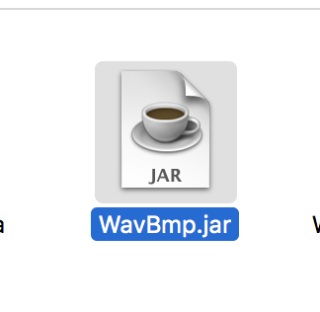

This shows the commands you use to create the above WavBmp.jar for your own reference, please be in the same folder as the source files before running commands

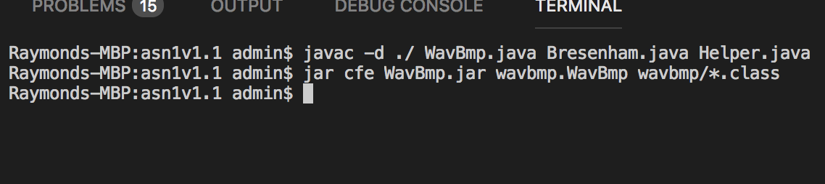

The program is very simple, there are three areas that you only need to know about.

1. The “Open File…” button opens a dialog for the user to search and select a WAV or BMP file to load.
2. The “Next…” button is only ENABLED when you load a BMP which allows the user to refresh and show stuff like the histograms, grayscale, 1.5x brighter image, and order dithering of the BMP. If you load a WAV file it will be disabled.
3. The number of Samples and Maximum Sample Value is only available for WAV files, and it will be empty of values if you load a BMP file.

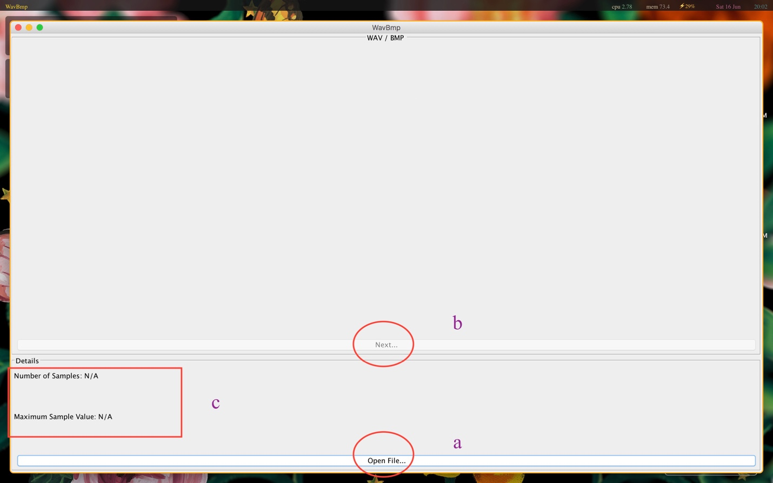

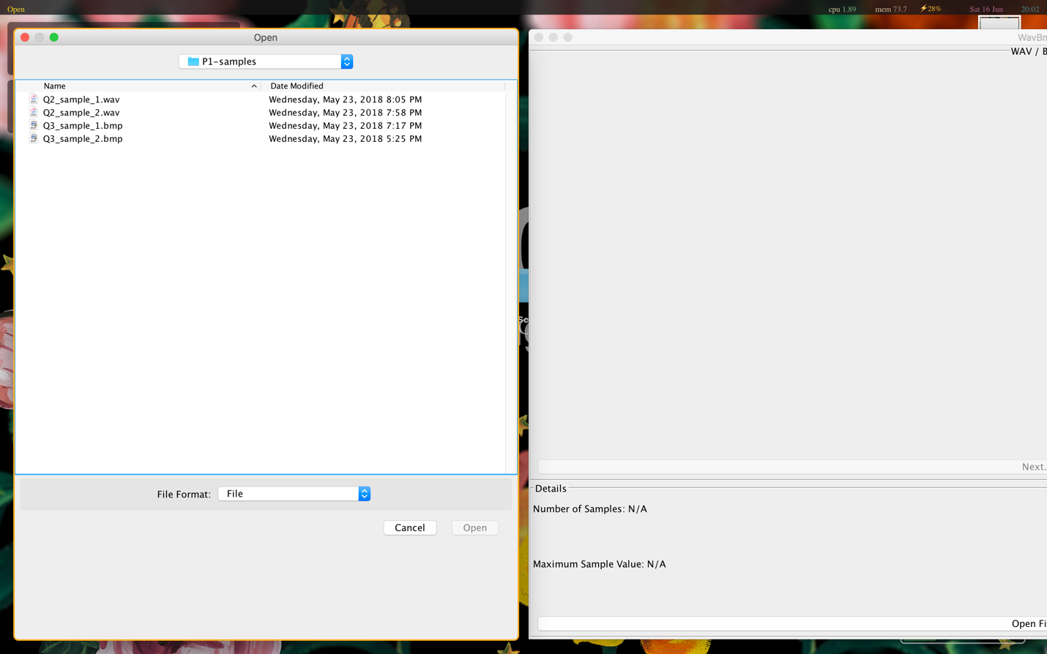

Sample screenshots of program loading either a BMP or WAV file…